**KENDRIYA VIDYALAYA, SECTOR-31,D CHANDIGARH**



**ACADEMIC YEAR : 2020-21**

**PROJECT REPORT ON**

**“CHATTING & LOGIN REGISTER SYSTEM”**



**ROLL NO : 21**

**NAME : UPENDER SINGH LAKHWAN**

**CLASS : XII-A**

**SUBJECT : COMPUTER SCIENCE**

**SUBMITTED TO : MR. ISHWAR DAS**

## KENDRIYA VIDYLAYA SECTOR-31 D CHANDIGARH



# **CERTIFICATE**

This is to certify that ______________________________________ Roll No: __________________________ has successfully completed the project Work entitled **"SOCIAL MEDIA SYSTEM."** in the subject Computer Science laid down in the regulations of CBSE for the purpose of Practical [ Examination in Class XII to be held in Kendriya Vidyalaya Sector-31.

**Mr. Ishwar Das**

PGT Comp Science

Student Name: _______________

Signature:

Date:

 **ACKNOWLEDGEMENT**

Apart from the efforts of me, the success of any project depends largely on the encouragement and guidelines of many others. I take this opportunity to express my gratitude to the people who have been instrumental in the successful completion of this project.

I express deep sense of gratitude to almighty God for giving me strength for the successful completion of the project.

I express my heartfelt gratitude to my parents for constant encouragement while carrying out this project.

I gratefully acknowledge the contribution of the individuals who contributed in bringing this project up to this level, who continues to look after me despite my flaws,

I express my deep sense of gratitude to the luminary **The Principal, Kendriya Vidyalaya Sector-31** who has been continuously motivating and extending their helping hand to us.

I express my sincere thanks to the academician The **Vice Principal, Kendriya Vidylaya Sector-31**, for constant encouragement and the guidance provided during this project

My sincere thanks to **Mr. Ishwar Das**, A guide, Mentor all the above a friend,who critically reviewed my project and helped in solving each and every problem, occurred during implementation of the project

The guidance and support received from all the members who contributed and who are contributing to this project, was vital for the success of the project. I am grateful for their constant support and help.

 **INTRODUCTION**

"**Chatting & Login Register System**" This project is fully dynamic. In this program you have to register yourselves by using your Email, which would be used to receive One time Password for authentication. To start chatting you have to provide a lobby ID where you can enter and ask your friend to enter the chat and start chatting. This project basically gives an idea of how a real login/register system works with an OTP system. In this program you can add more things to make it more functional.

 **OBJECTIVES OF THE PROJECT**

The objective of this project is to let the students apply the programming knowledge into a real- world situation/problem and exposed the students how programming skills helps in developing a good software.

1. Write programs utilizing modern software tools.
2. Apply object oriented programming principles effectively when developing small to medium sized projects.
3. Write effective procedural code to solve small to medium sized problems.
4. Students will demonstrate a breadth of knowledge in computer science, as exemplified in the areas of systems, theory and software development.
5. Students will demonstrate ability to conduct a research or applied Computer Science project.

 **CODE**

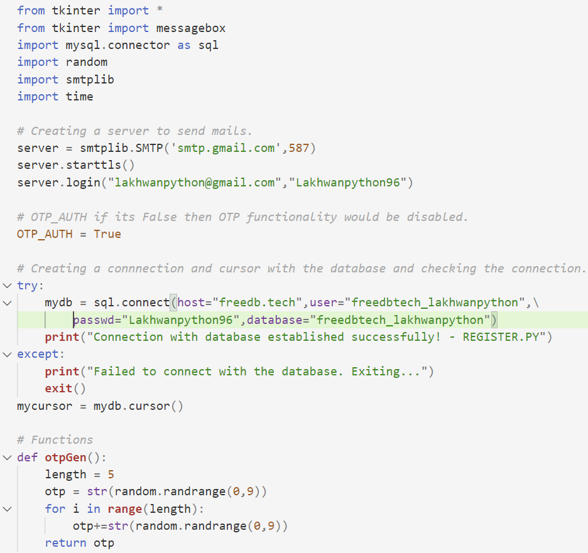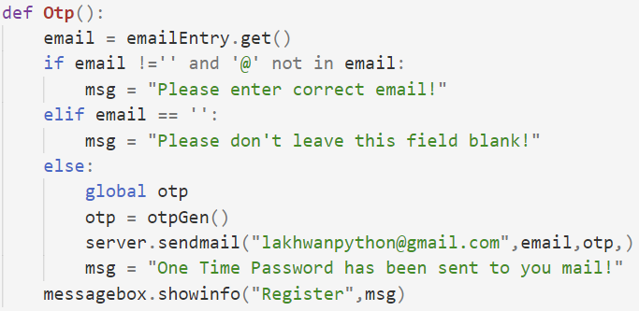

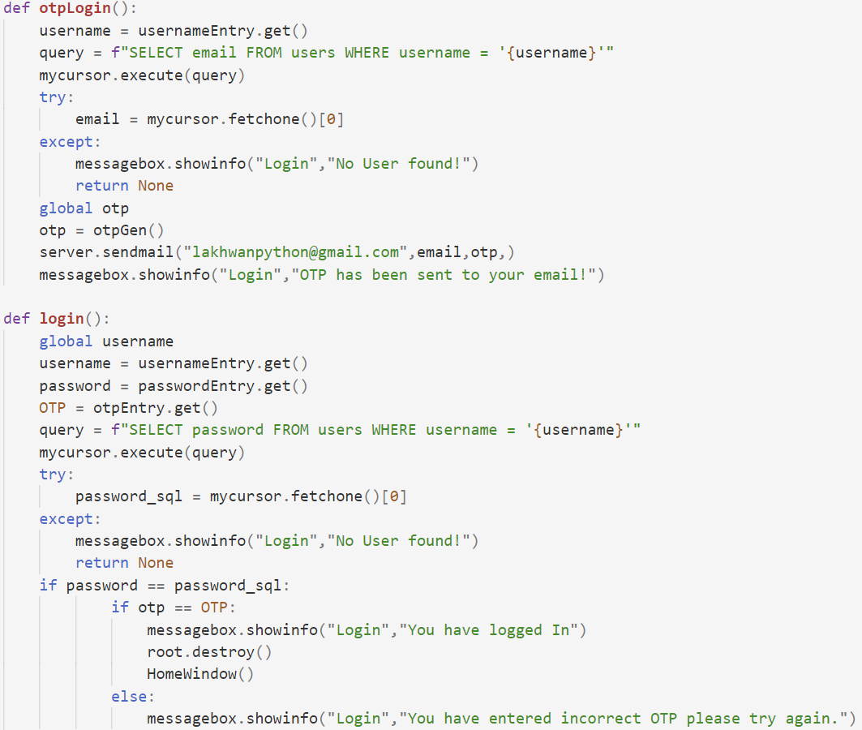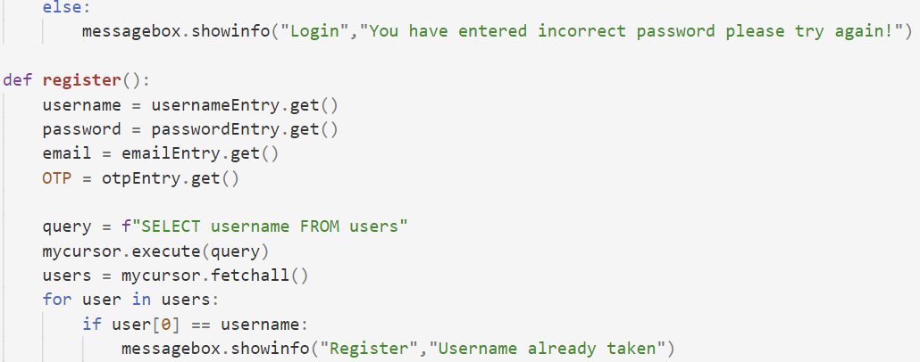

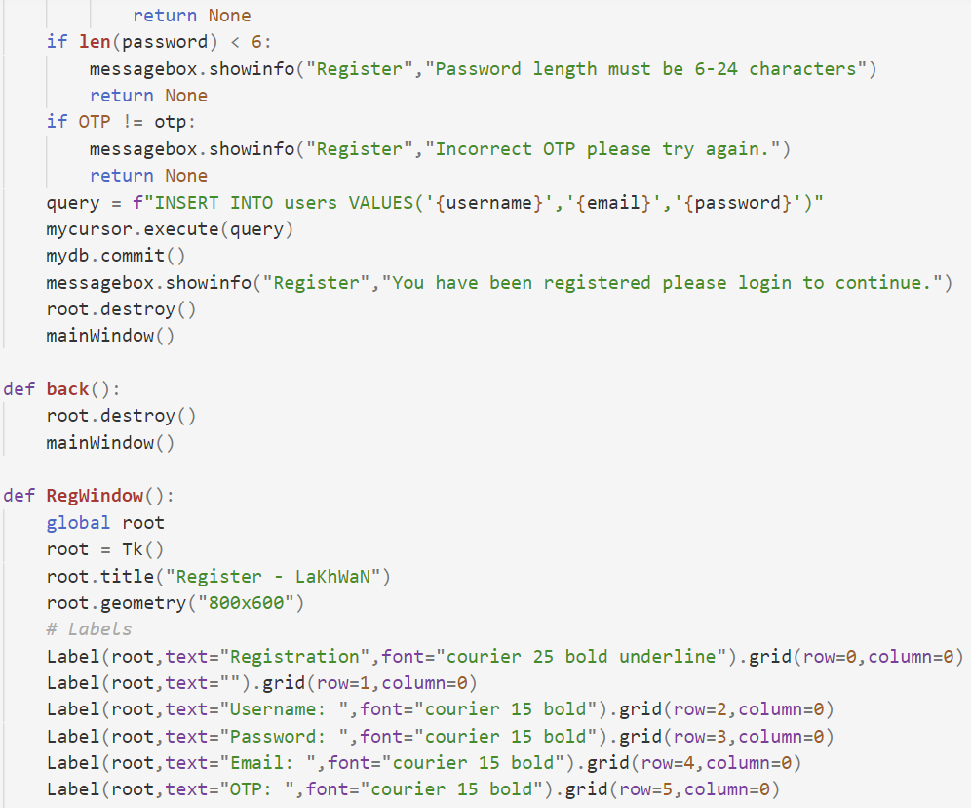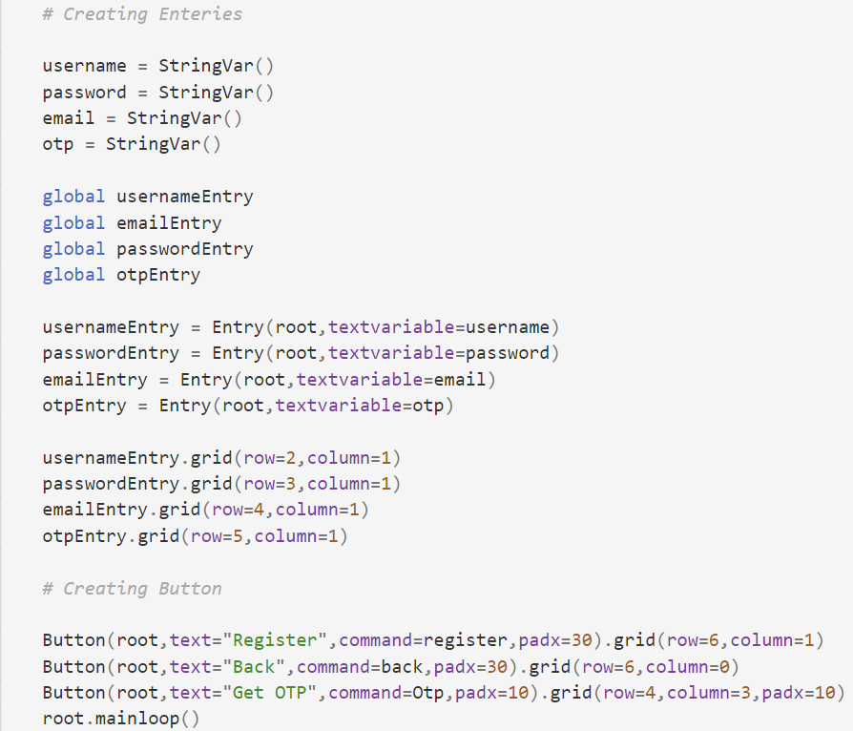

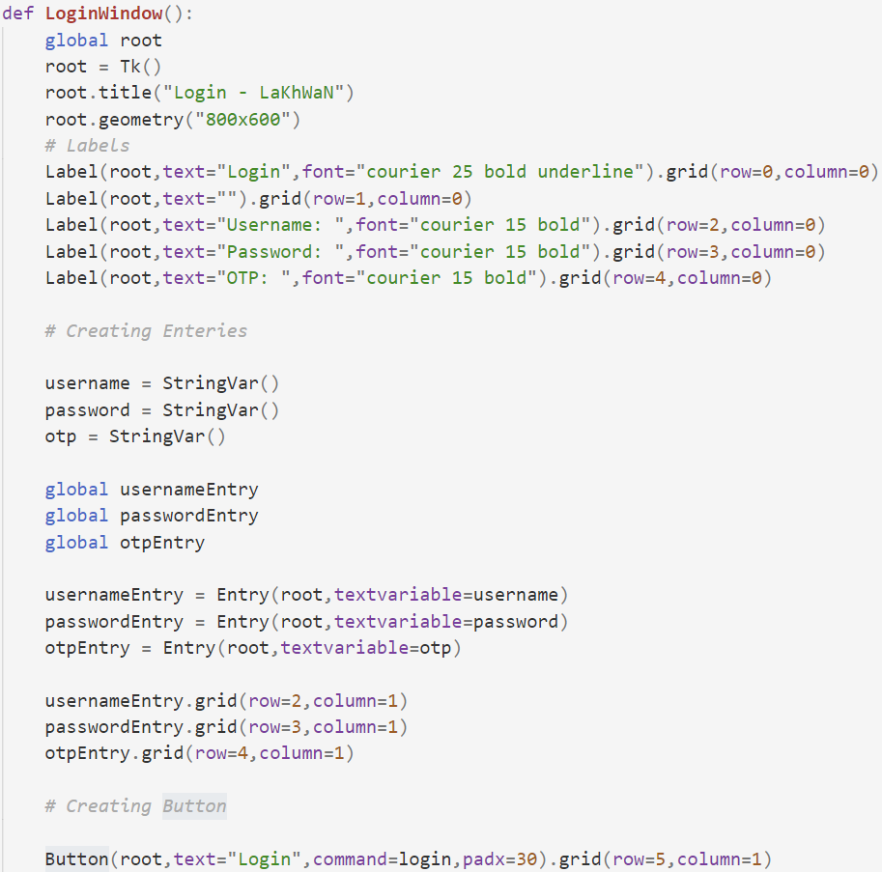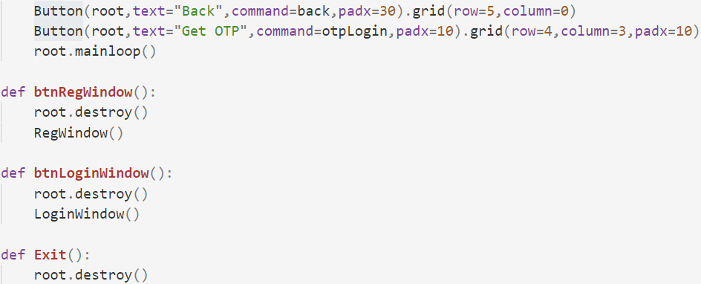

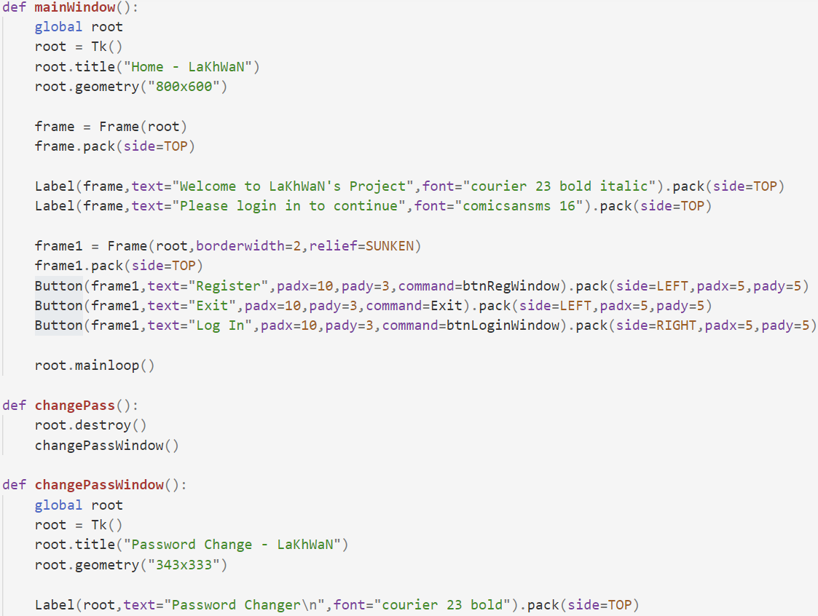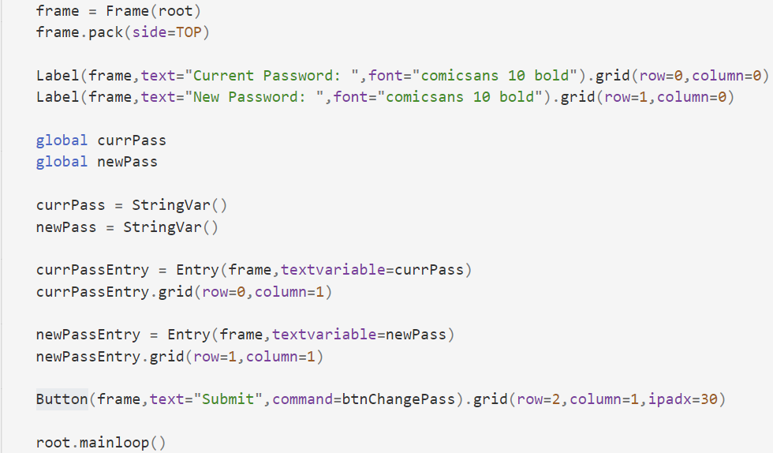

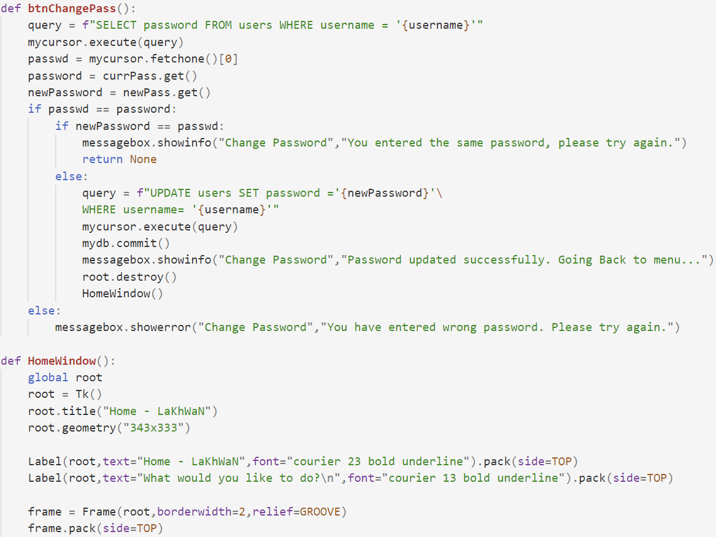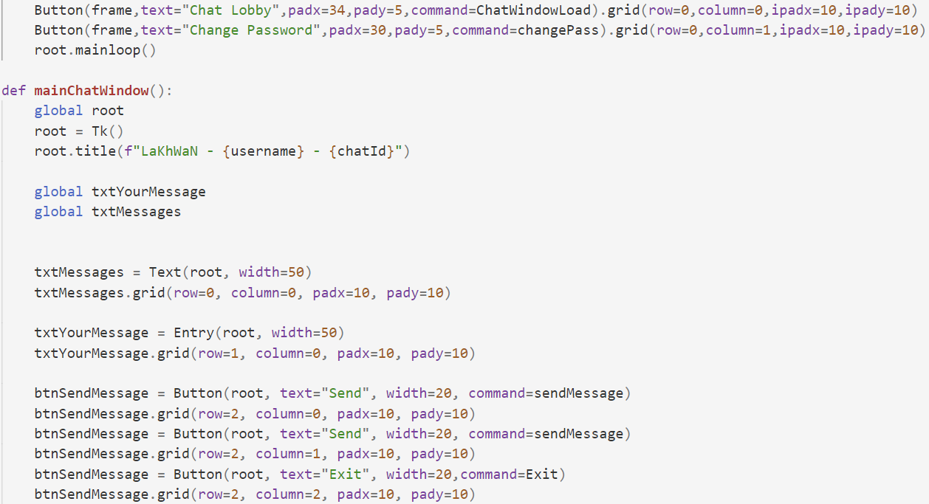

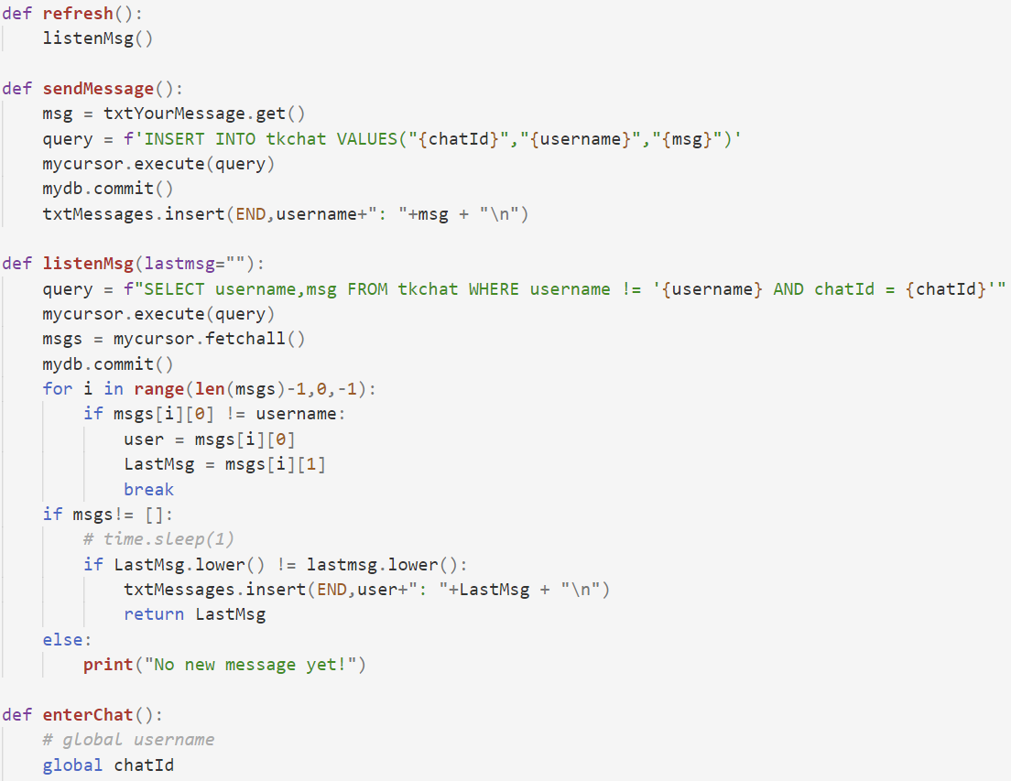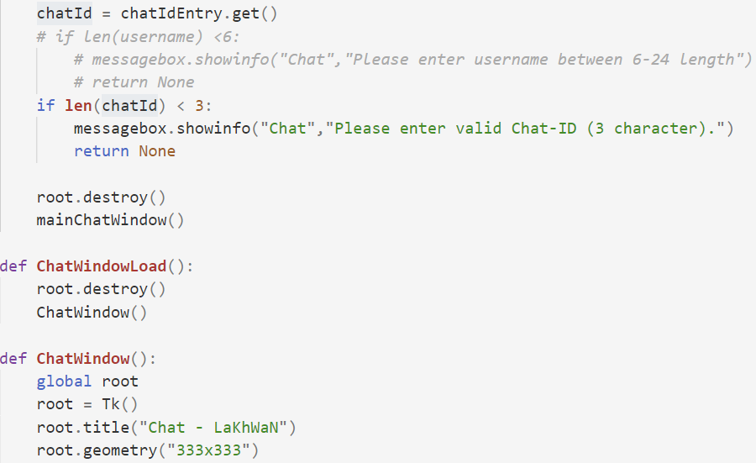

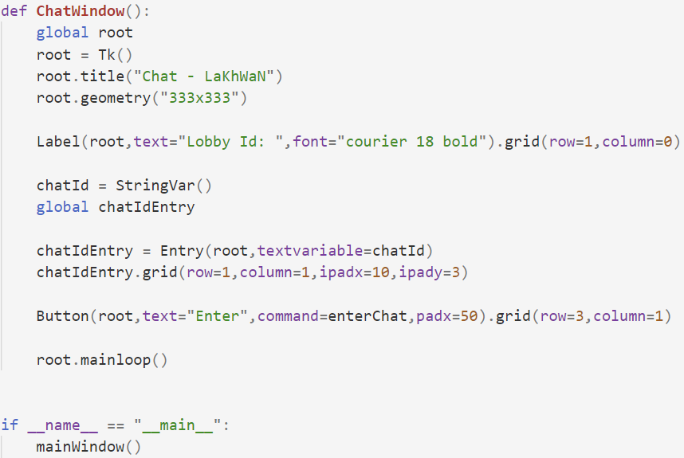

**OUTPUTS**

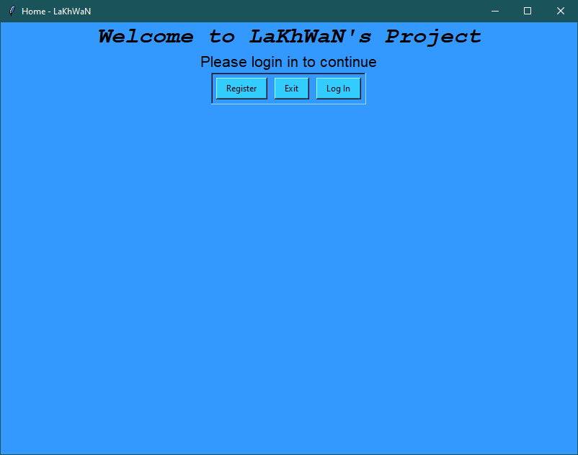

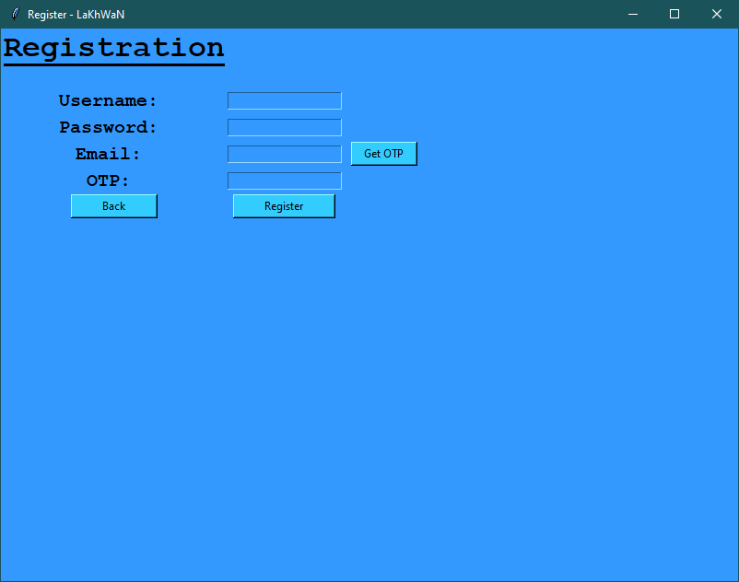

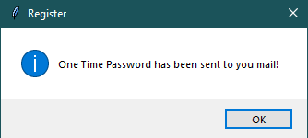

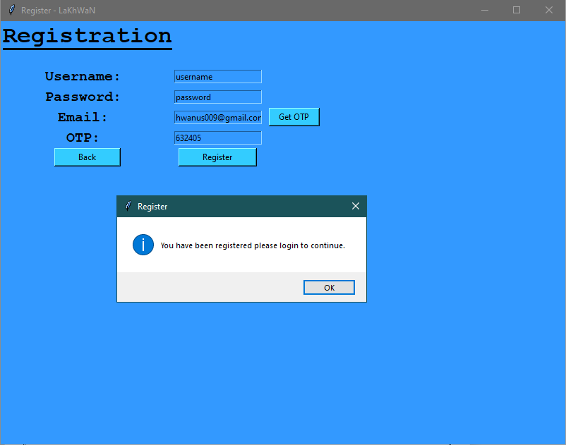

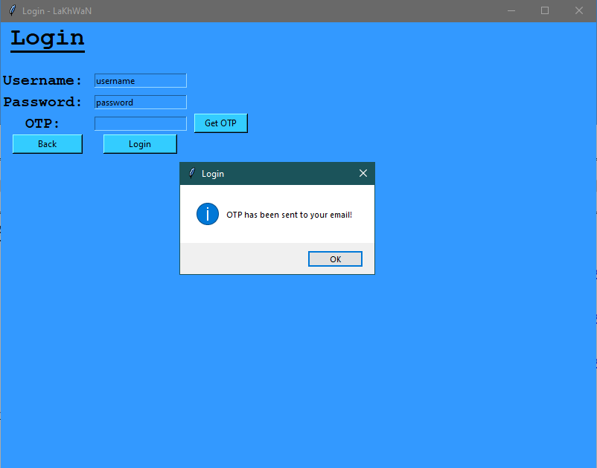

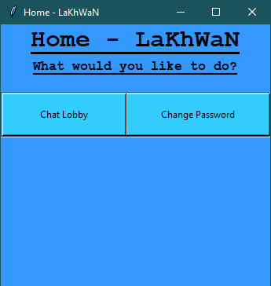

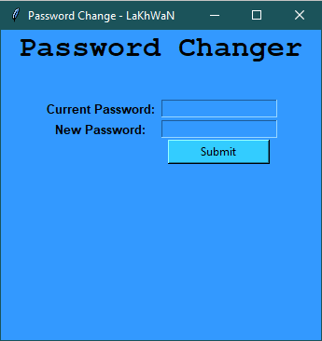

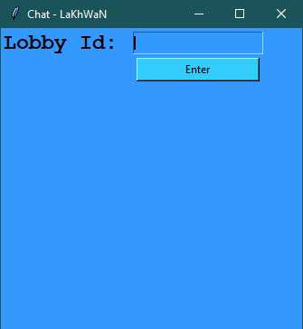

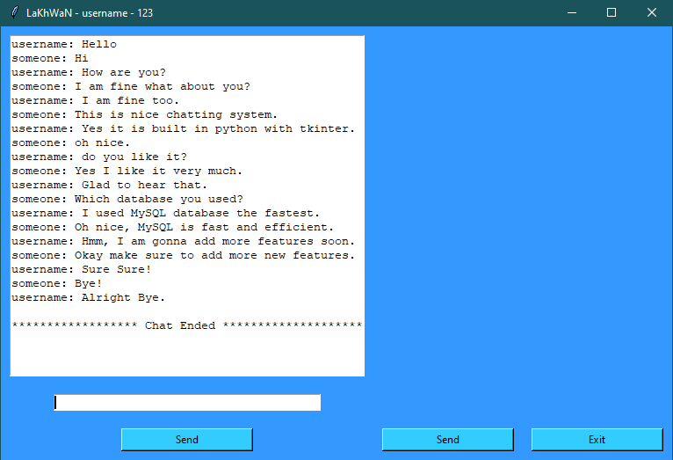

 **HARDWARE AND SOFTWARE REQUIREMENTS**

1. OPERATING SYSTEM : WINDOWS 7 AND ABOVE

II. PROCESSOR : PENTIUM(ANY) OR AMD

IV. RAM : 512MB+

V. Hard disk : SATA 40 GB OR ABOVE

VI. MONITOR 14.1 or 15 - 17 inch

IX. Keyboard and mouse

 **SOFTWARE REQUIREMENTS:**

1. Windows OS
2. Python

 **INSTALLATION PROCEDURE**

* Install python.
* Double click on the “LaKhWaN.py” to start the software.
* Then you can enjoy!

 **REFERENCES**

1. ***Forums and Discussion: <https://stackoverflow.com>***
2. ***XAMPP (MySQL Interface):***

***<https://www.apachefriends.org/download.html>***

1. ***Visual Studio Code: <https://code.visualstudio.com/download>***
2. ***Hex Color Picker: <https://www.w3schools.com/colors/colors_picker.asp>***

***\*\*\****